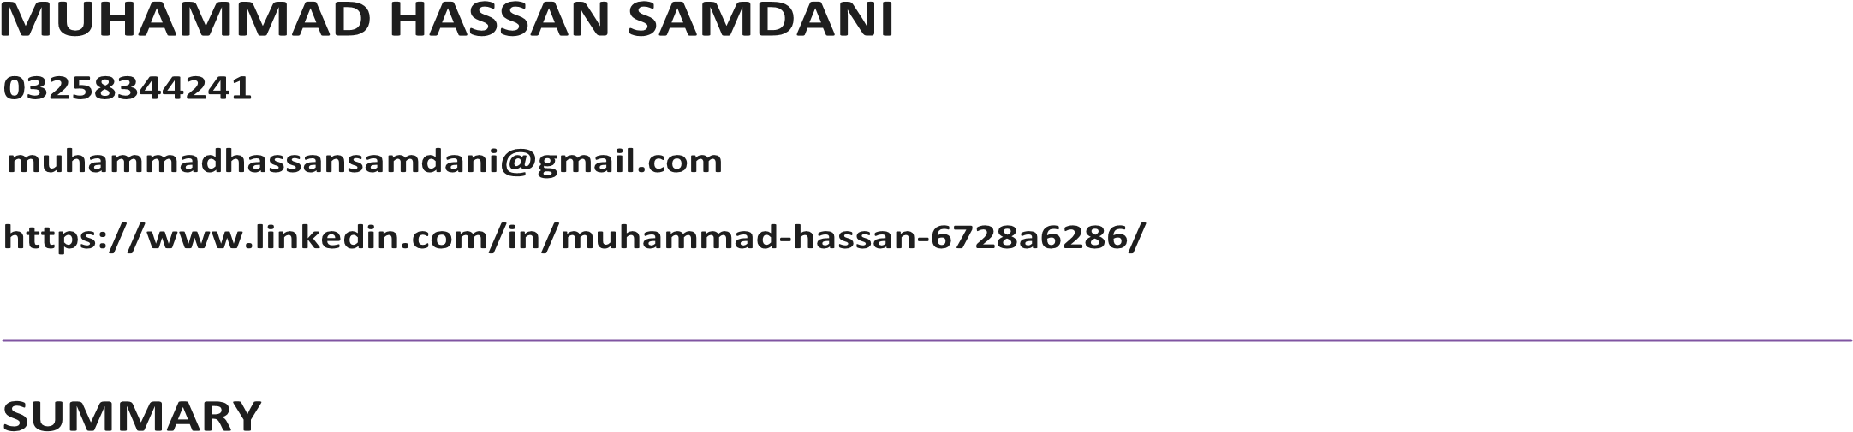
To obtain a challenging position in a reputable organization where I can utilize my skills, contribute to the team's success, and grow both personally and professionally while supporting the company’s goals and vision. With over 2 years of experience, I am a skilled graphic designer and web designer. Passionate about visual storytelling, I translate ideas into captivating visuals. With a strong design foundation and keen eye for detail, I specialize in creating impactful designs that communicate effectively.

EXPERIENCE
Graphic and Web Design 2021 – Presently
- Designed logos, banners, and other visual content.
- Created responsive website layouts using HTML, CSS, and JavaScript, ensuring crossbrowser compatibility and mobilefriendliness.
- The individual utilized Adobe Creative Suite (Photoshop and Illustrator) to create visually appealing graphics for websites and social media platforms.
- Developed custom WordPress themes, optimizing user interfaces for improved engagement.
Junior Web Developer 2023 – Presently
- The individual assisted in the creation of client websites by coding and debugging both frontend and backend functionality.
- The focus has been on improving user interfaces through responsive design and accessibility standards.
- Participated in the entire web development lifecycle, from concept to deployment, utilizing technologies like HTML5, CSS3, JavaScript, React and PHP.

EDUCATION
Bachelors of Engineering (Electronics) October 2023-2027
Quaid-e-Azam University Islamabad (QAU) Presently
Intermediate F.Sc Pre-Engineering 2021- July2023
HAMZA APSACS Rawalpindi Grade - A
Matriculation 2019- July2021
HAMZA APSACS Rawalpindi Percentage – 91.5% Grade – A+

ADDITIONAL INFORMATION
- Technical Skills: Graphic Design, Web Development, Arduino, Web Design, Programming languages.
- Languages: English, Urdu
- Reference: Will be furnished on demand.

